ABLEKUMA CENTRAL MUNICIPAL ASSEMBLY
ENVIRONMENTAL HEALTH AND SANITATION UNIT
HEALTH AND HYGEINE EDUCATION AT SCHOOLS DURING THE FIRST QUARTER (JANUARY –MARCH 2023)
INTRODUCTION
Hygiene refers to the practices associated with the protection of health and healthy living. Students knowledge of hygiene is reflected to be provided by parents or school. It is something with a direct effect on health and related to sociocultural factors.
Poor health hygiene practices can lead to communicable diseases basically with developing countries. In many parts of Ghana, 31% of all deaths are caused by infectious diseases. In Ghana as a developing country, primary causes of morbidity and mortality among young children are acute respiratory and intestinal infections. School is a place which not only provides education to children but also learning environment.
The foundations of lifelong responsibility for the maintenance of personal hygiene are childhood, which is important for a healthy childhood, for a healthy adulthood and for the development of positives values about health and issue of health services. Diarrhea diseases, skin diseases, worm infections and dental diseases are mostly commonly associated with personal hygiene. The present inadequate knowledge base hinders the development of improved strategies for enhancing the maintenance of personal hygiene, which is of great importance to decrease the burden of communicable disease amongst young children.
OBJECTIVES
As Environmental Health Officers, preventives measures is one of the key essentials to achieving part of our set target. Our objective for this initiative amongst others are stated below
- To find out the current knowledge and practices regarding personal hygiene among school children
- To identify any misconception among them regarding the maintenance of personal hygiene
- To identify knowledge and misconceptions regarding health-related conditions
- To educate and promote good personal hygiene behavior among them
- To create awareness on the dangers engulfing poor personal hygiene practices
ACTIVITY
On the 18th of January 2022, a team made up of the Municipal Environment Health Officer (MEHO), together with her deputy and the ward officers visited and educated Salvation Army school, Daawatu Islamic school, Al-Riyyad Islamic school, Royal family school, Mercy schools and faith school to promote health among the pupils.
List of topics discussed among others
- Personal and oral hygiene practices
- Frequent hand washing practices
- Trimming of nails and washing of hairs
- Wearing of fresh, clean and warm ironed clothes
- Regular showering
- Proper food hygiene practice
CHALLENGES
Every undertaken activity assigned, comes with their relative unique challenges, and ours was not an exception. The listed below among others were some challenges met;
- Some discussions meant for ladies only could not be discussed in the presence of the males.
- Unavailability of transport to convey health educational team.
CONCLUSION AND RECOMMENDATIONS
A highly satisfactory result was achieved after our educative engagement with the student.
School-based hygiene education is vital to decrease the rates of transmissible diseases. Children are more receptive to learning and are very likely to adopt heathy behaviors at a young age. They can also be agents of change by spreading what they have learned in school to their families and community members.
ACKNOWLEDGEMENT
We sincerely extend our warm appreciation to the headmasters/mistresses and the teaching staffs of the schools for their valuable help extended during the education.

APPENDIX
Attached are the picture gallery of the health education training that was undertaken

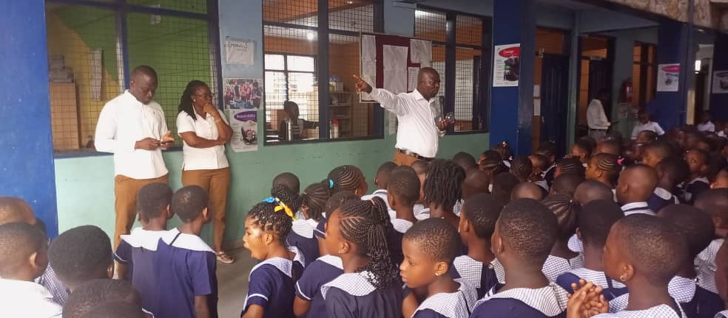

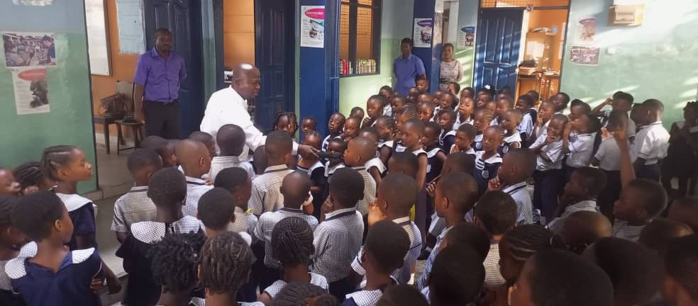

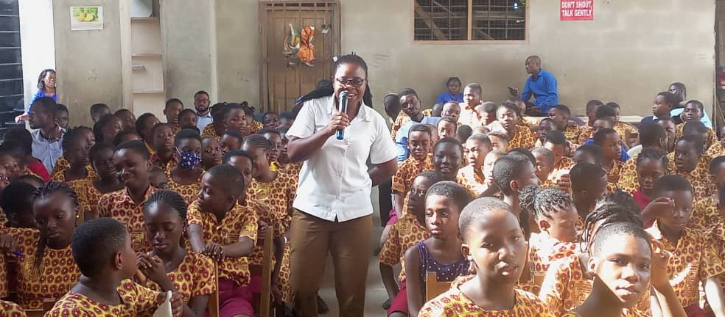

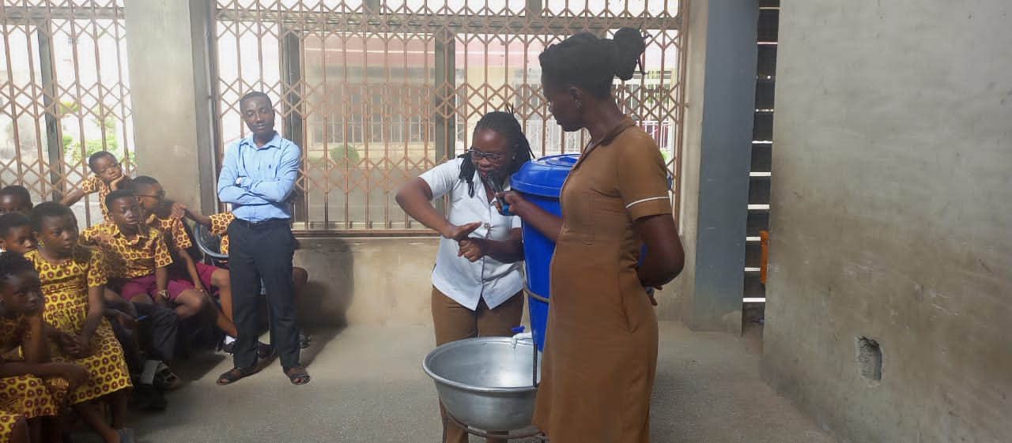

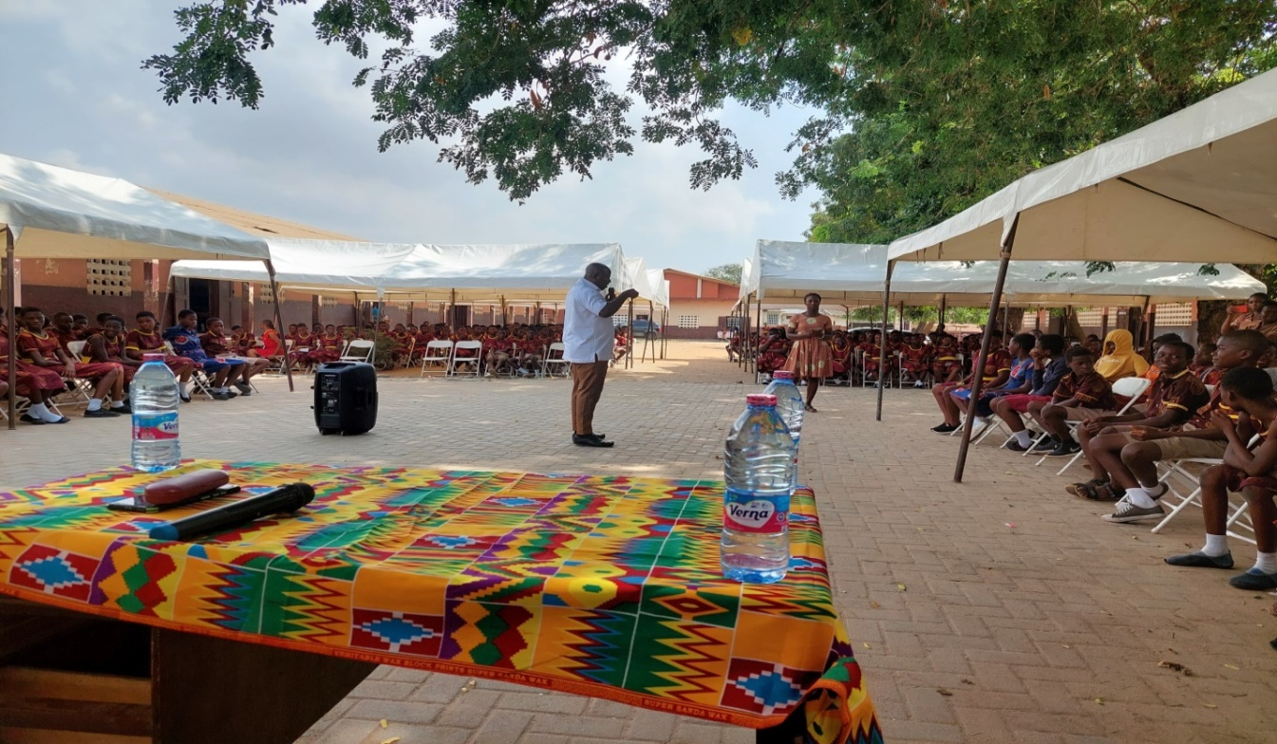
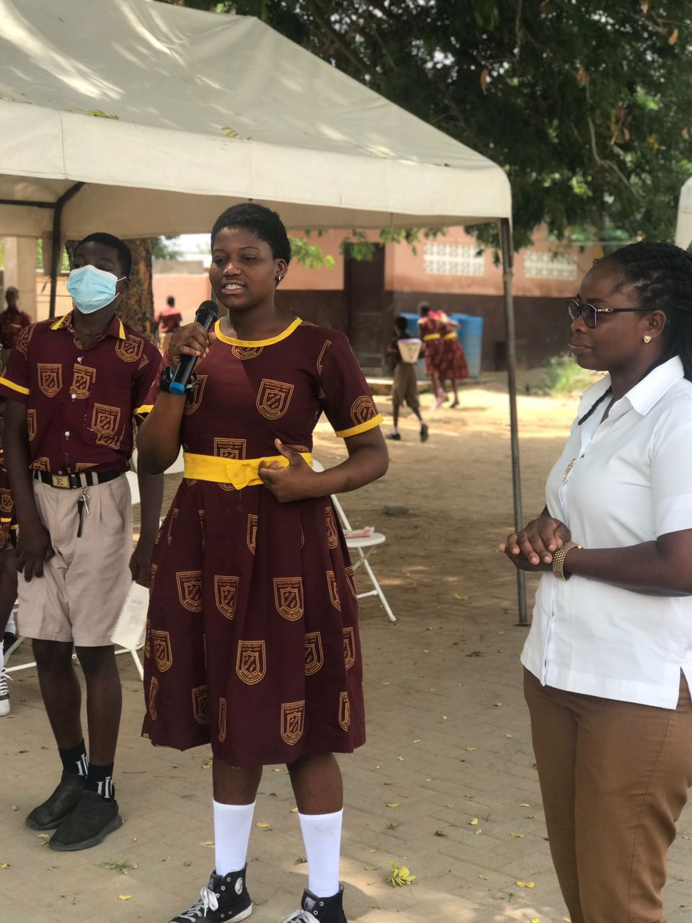

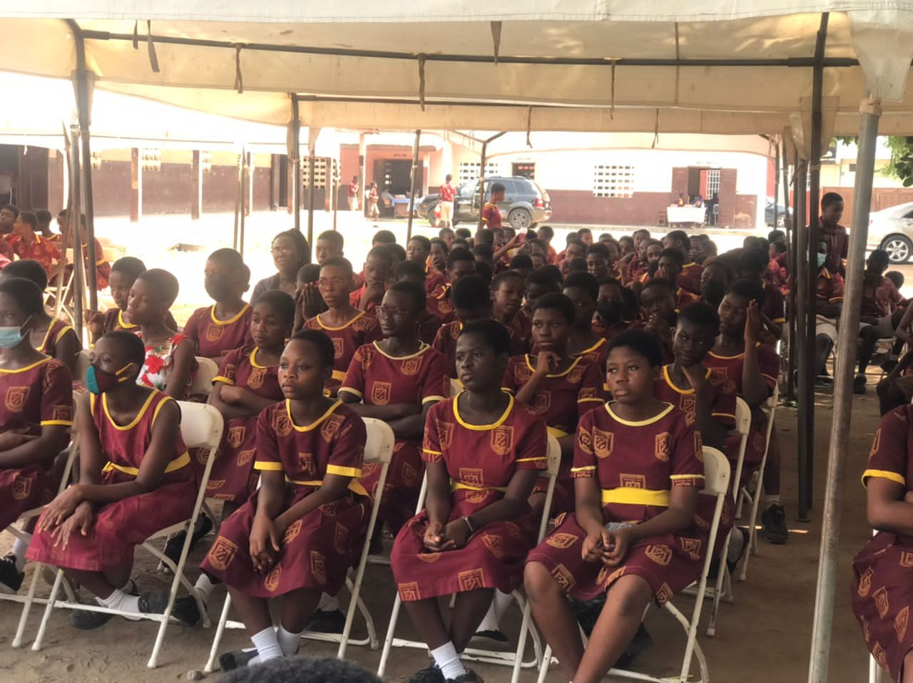

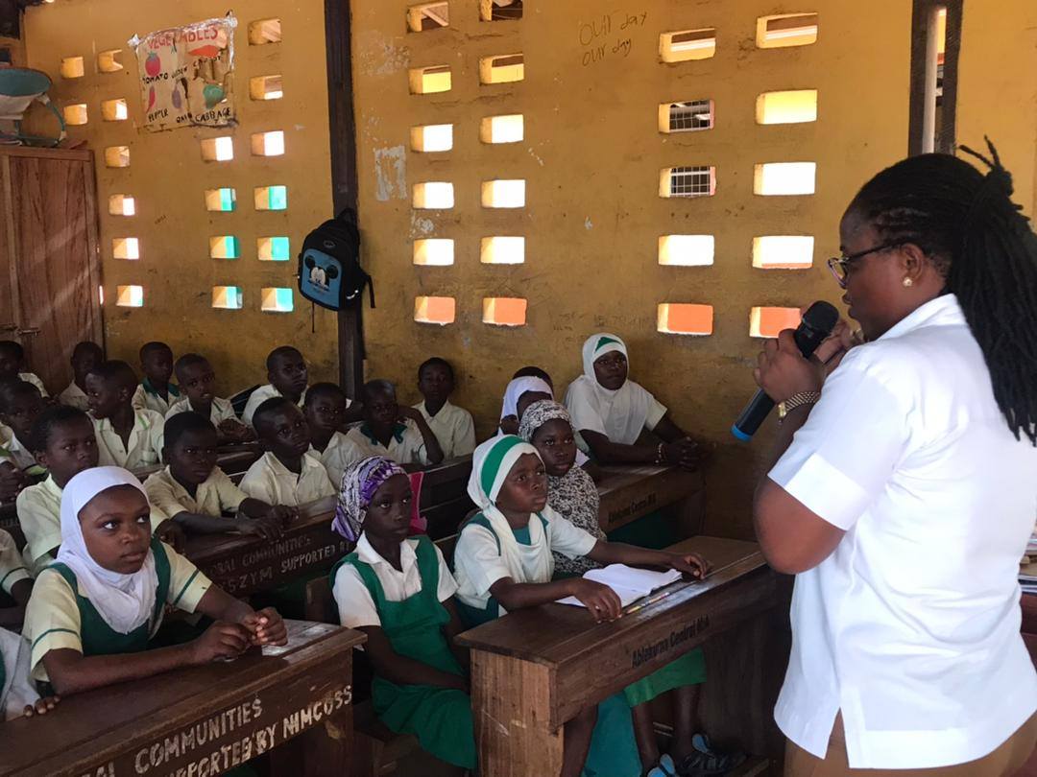

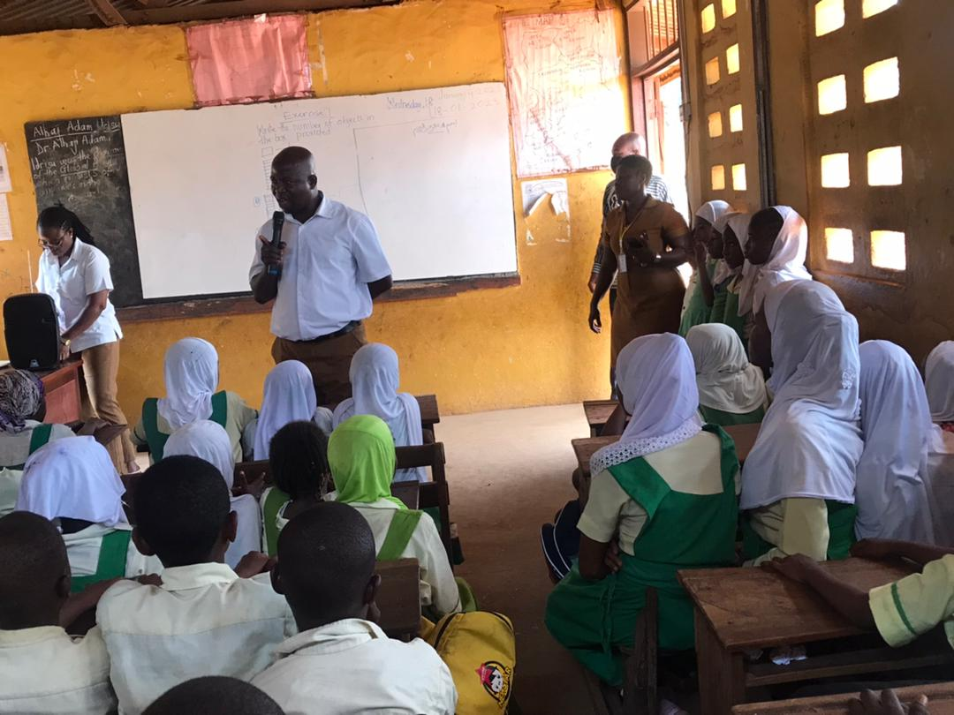

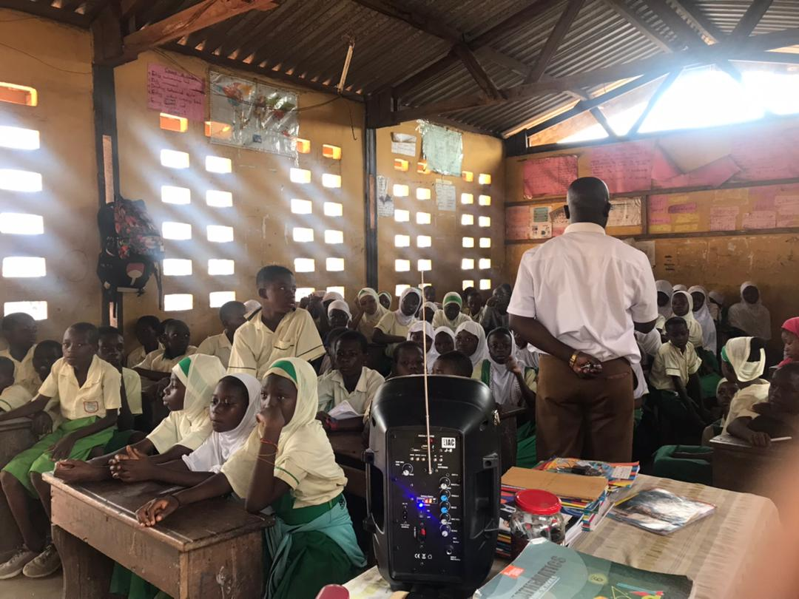

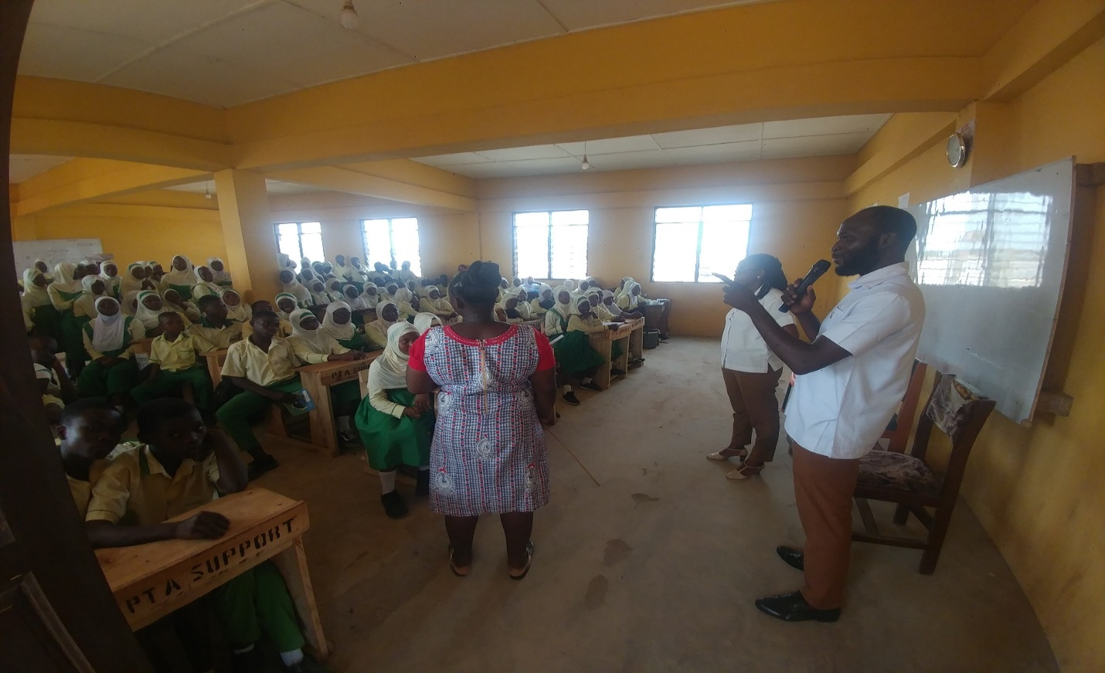

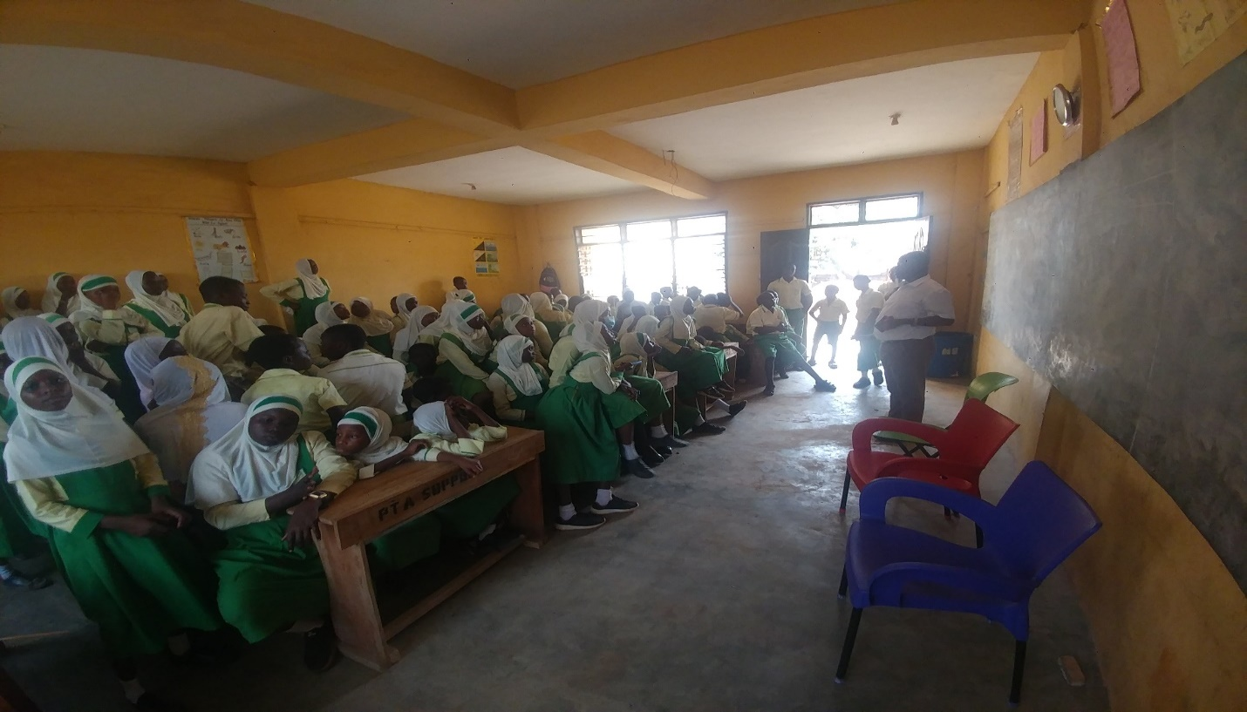

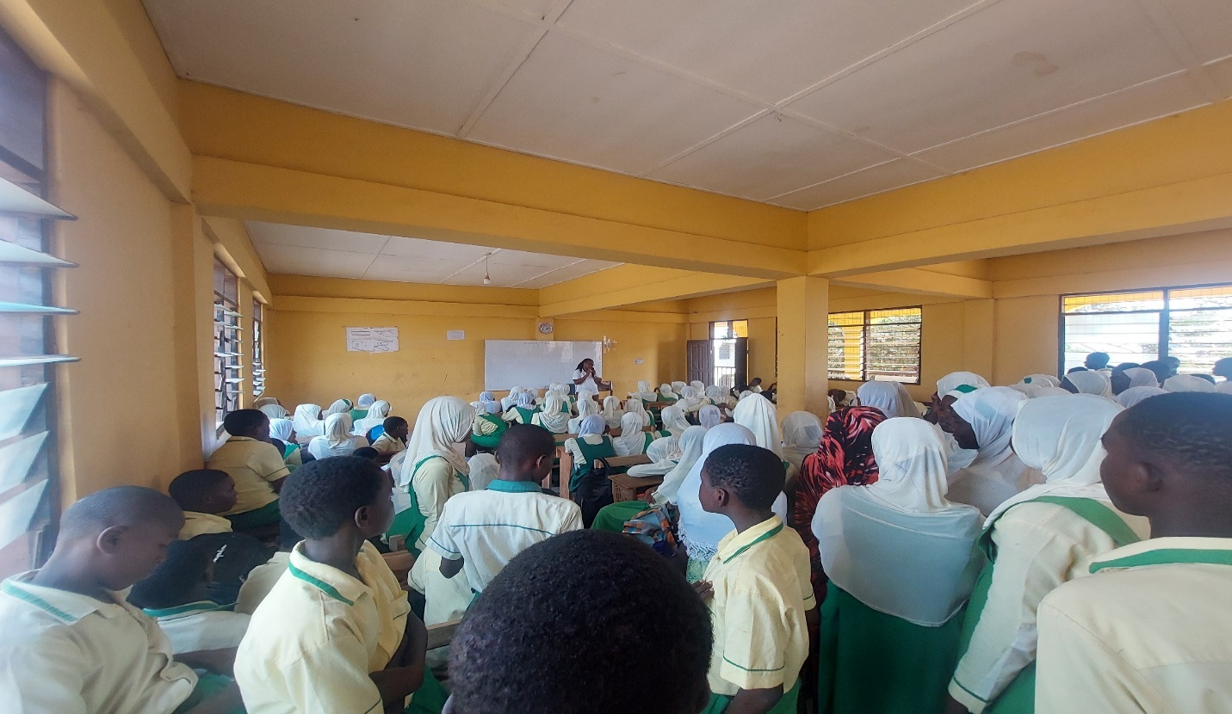

Compiled By:

Bridget Seyram Diapim
(Municipal Environmental Health Officer)

